Compiler Homework Chapter 3

5. Write DFAs that recognize the tokens defined by the following regular expressions:
(a) (a | (bc) *d)+
(b) ((0 | 1) * (2 | 3)+) | 0011
(c) (a Not(a))*aaa

Sol: (a)
1
2
3
6
λ
8
λ
λ
λ
b
a
d
4
7
5
c
λ
λ
λ

A {1,2,4,6} B{1,2,3,4,6,8}
C {5} D{1,2,4,6,7,8} E{4,6}

C
E
B
D
A
b
a
c
d
b
a
b
b
d
d
d
a

(b)
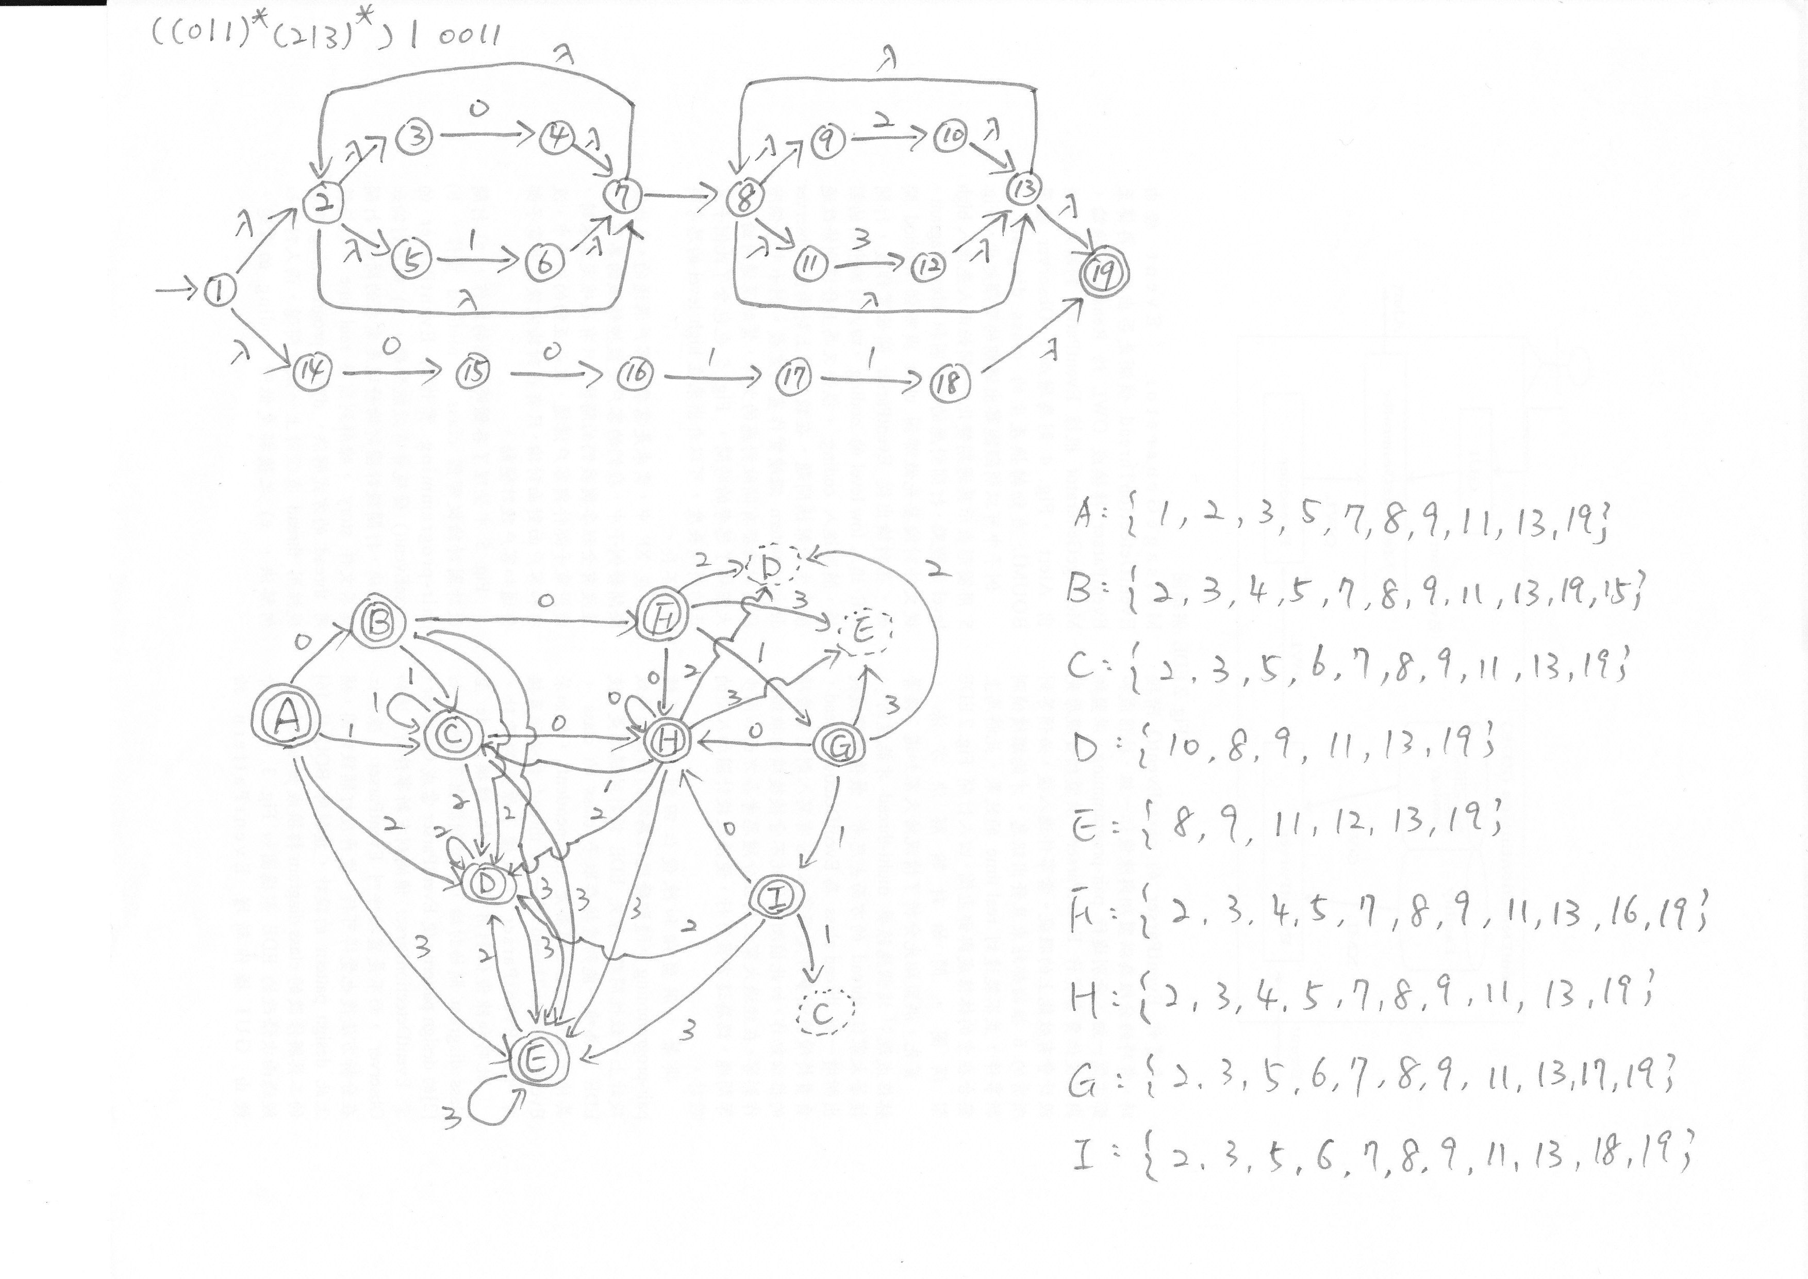

(c)
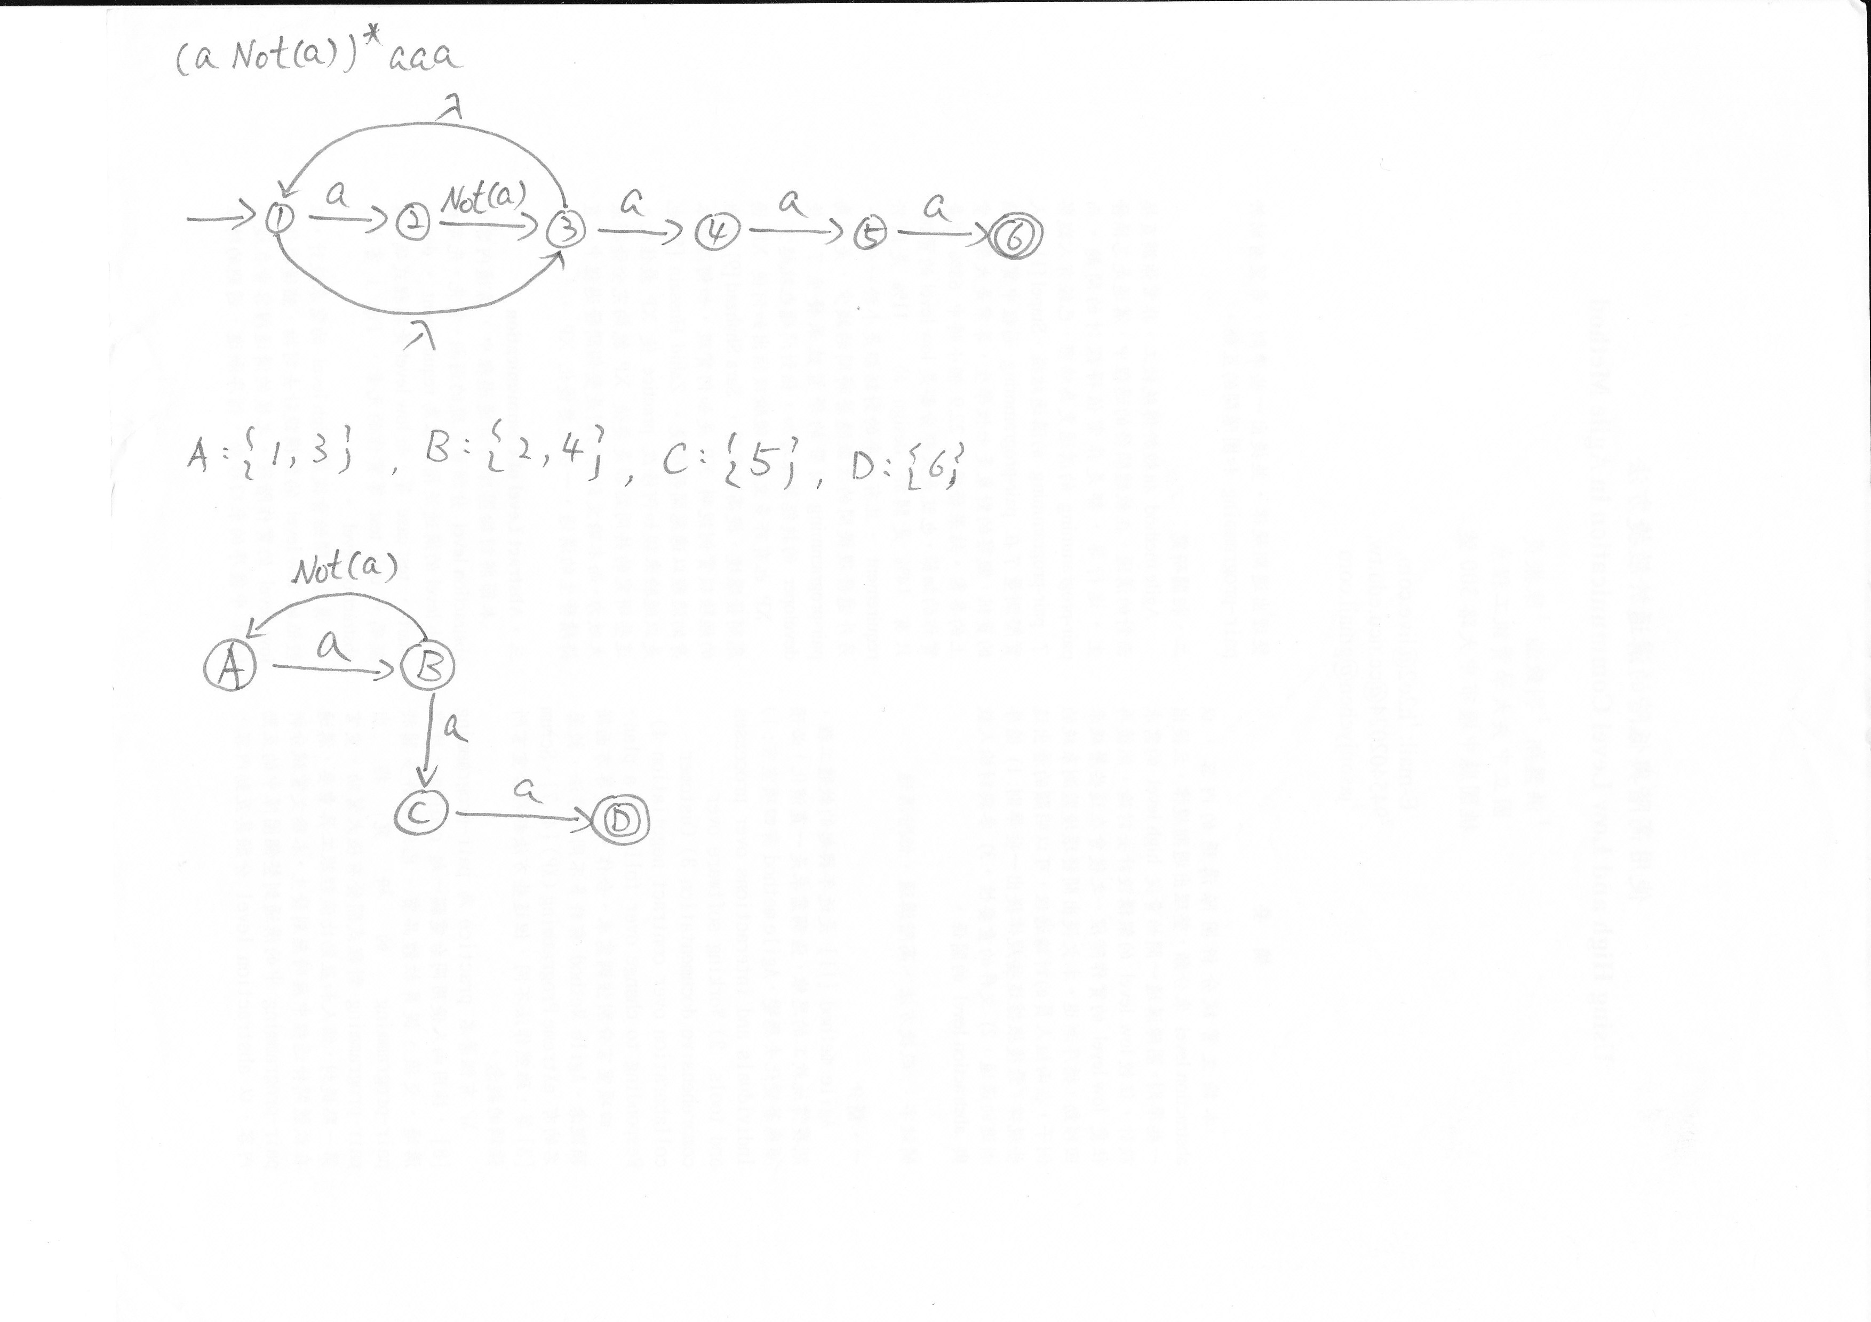

6. Write a regular expression that defines a C-like, fixed-decimal literal with no superfluous leading or trailing zeros. That is, 0.0, 123.01, and 123005.0 are legal, but 00.0, 001.000, and 002345.1000 are illegal.

Sol:
Let DNOTZ be the set of digits from 1 to 9.
Let D be the set of digits from 0 to 9.

Define (0 | (DNOTZ D*) . (0 | (D* DNOTZ)

9. Define a token class AlmostReserved to be those identifiers that are not reserved words but that would be if a single character were changed. Why is it useful to know that an identifier is “almost” a reserved word? How would you generalize a scanner to recognize AlmostReserved tokens as well as ordinary reserved words and identifiers?

Sol:
擴充原來Reserved 的DFA，例如：
假設有一個 reserved word為 while
其DFA如下：
w
h
i
l
e
1
2
3
4
5
6

當執行到state 6時，scanner會得知input為reserved word
擴充後的DFA如下：

1
2
3
4
5
6
w
h
i
l
e

j
l
7
l
l
…

9

如上圖，將原來reserved word其中一個character其可能的錯誤其況擴充為新的state，而當執行到end state (state 6)時，只將其認為是一個identifier，到了parser階段時，再透過parser去確認。

20. Show that the set { [k ]k | k > 1 } is not regular.
Hint: Show that no fixed number of FA states is sufficient to exactly match left and right brackets.

Sol:
因為在regular express中，無法定義 [ 產生 k 次與 ] 產生 k 次，這兩個k會相等，所以如果有input token為 [[[]]時，在執行DFA時，也會認為是正確的token，故the set { [k ]k | k > 1 } is not regular。

22. Let Rev be the operator that reverses the sequence of characters within a string. For example, Rev(abc) = cba. Let R be any regular expression. Rev(R) is the set of strings denoted by R, with each string reversed. Is Rev(R) a regular set? Why?

Sol:
Rev(R) 是regular set。
在DFA中會存在一個backwards path。
例如：一個 string “abc” 屬於R，其DFA為

1
2
4
a
b
c
3

上圖中state 1是start state，state 4是end state。
若將其role互換，即start 與 end互換，而其中的箭頭方向也反轉（即原先箭頭從3到4，反轉後從4到3），此時從start state到end state會有一條path，剛好等於Rev (abc)=cba (backwards path)，所以Rev(R)也是regular set。

27. Let Seq(x,y) be the set of all strings (of length 1 or more) composed of alternating x’s and y’s. For example, Seq(a,b) contains a, b, ab, ba, aba, bab, abab, baba, and so on. Write a regular expression that defines Seq(x,y).
Let S be the set of all strings (of length 1 or more) composed of a’s, b’s, and c’s, that start with an a and in which no two adjacent characters are equal. For example, S contains a, ab, abc, abca, acab, acac,…but not c, aa, abb, abcc, aab, cac,….
Write a regular expression that defines S. You may use Seq(x,y) within your regular expression if you wish.

Sol:
(a) Seq(x, y) = (x (yx)⋆(y |λ)) | (y (xy)⋆(x |λ))

(b) S = a ((b Seq(a, c))⋆(b |λ)) | ((c Seq(a, b))⋆(c |λ))

28. Let Double be the set of strings defined as { s | s = ww }. Double contains only strings composed of two identical repeated pieces. For example, if we have a vocabulary of the ten digits 0 to 9, then the following strings (and many more!) are in Double: 11, 1212, 123123, 767767, 98769876,…. Assume we have a vocabulary consisting only of the single letter a. Is Double a regular set? Why?
Assume we now have a vocabulary consisting of the two letters, a and b. Is Double a regular set? Why?

Sol:

(a) Double is a regular set，因為當vocabulary只有one letter “a”時，任何長度為偶數的string可以被定義為：(aa)+ 所以Double 是 regular set

(b) 當vocabulary包含 two letters時 (a, b)，無法定義出 identical repeating pieces，故Double is not a regular set。例如：要產生string “aabbaabb” 時，當產生出”aabb”後，我們無法透過regular express來定義產生string與前面的string一樣。

